**CHECK THE LEAP YEAR**

**FLOWCHART**

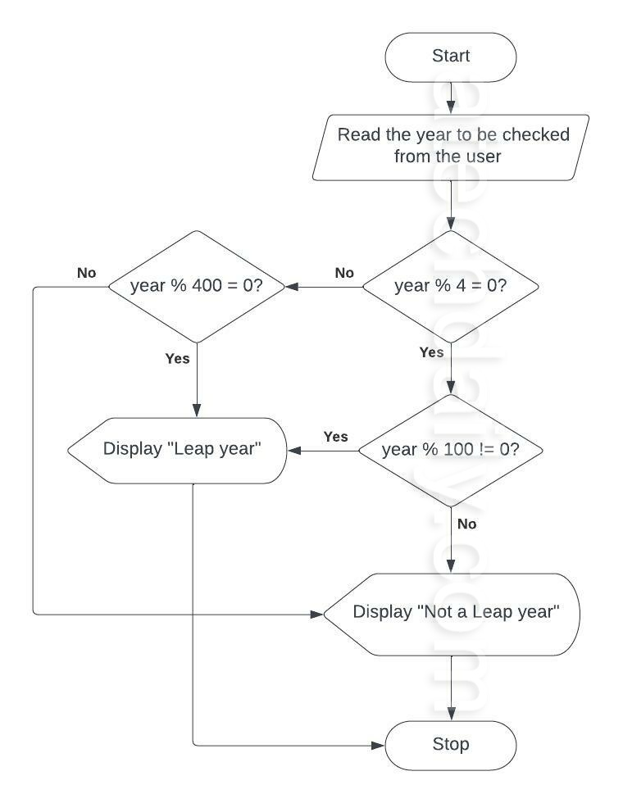

**PROGRAM**

# Python program to check if year is a leap year or not

year = 2000

# To get year (integer input) from the user

# year = int(input("Enter a year: "))

# divided by 100 means century year (ending with 00)

# century year divided by 400 is leap year

if (year % 400 == 0) and (year % 100 == 0):

print("{0} is a leap year".format(year))

# not divided by 100 means not a century year

# year divided by 4 is a leap year

elif (year % 4 ==0) and (year % 100 != 0):

print("{0} is a leap year".format(year))

# if not divided by both 400 (century year) and 4 (not century year)

# year is not leap year

else:

print("{0} is not a leap year".format(year))